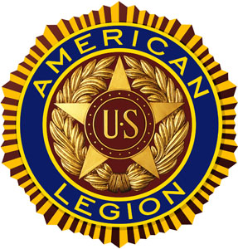 | The American Legion  Jonathan D. Rozier • Post No. 164  P.O. Box 1171 • Katy, Texas 77492  www.texasboysstate.com | 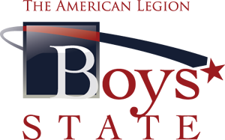

July 1, 2023
Name
Address
City, State, Zip

2023 Boys State Statesmen

This year’s Boys State event is over. We, at Jonathan D. Rozier Post 164 of the Texas American Legion hope you had a great experience. As recognition of your experience, please plan to attend a local American Legion meeting to accept a certificate of appreciation and to share your experience with the Legion members.

If you are unable to attend one of the scheduled meetings, we are requesting that each boy compose a letter describing their experience with the program. Upon receipt of the letter, your certificate will be mailed to your home. The letter may be emailed to:

BoysState@LegionPost164KatyTX.org

Or written on paper and sent to:

American Legion Post 164
PO Box 1171
Katy, TX 77492

Please stay safe and healthy

Harry R Woodstrom
Boys State Chairman

